OTHER EVALUATIONS (*):
Members | Task Details
Member 1 | 9 Questions and Expand - 100%

TASK ASSIGNMENT TABLE:
Content | Result
Average total time to complete the lab (1) | 3 hours
Video Link (2)
(if any)
Feedback (3) (if any)
+ Challenges
+ Suggestions …
Self-Assessment Score (4) | 10/10
(*): Sections (1) and (4) are mandatory.

Teacher: Phan Trung Phát

Name | ID
Trần Anh Tuấn | 24521943

NAME OF THE LAB
1

Question 1: What is the total packet capture time in each tested website and the total number of packets captured?

Evidence:
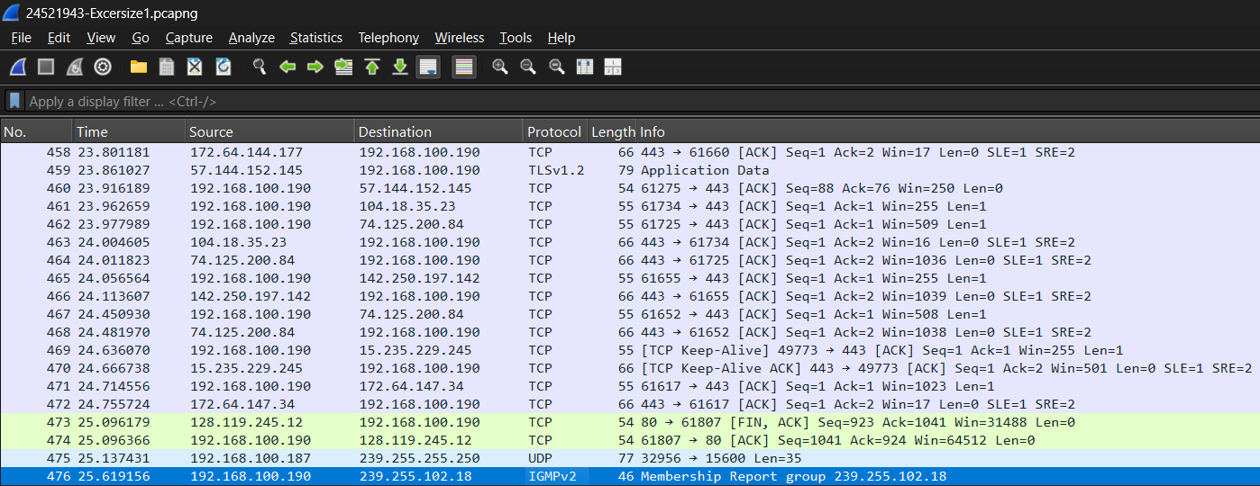

Figure 1. Total packets and time appear doing Exercise 1

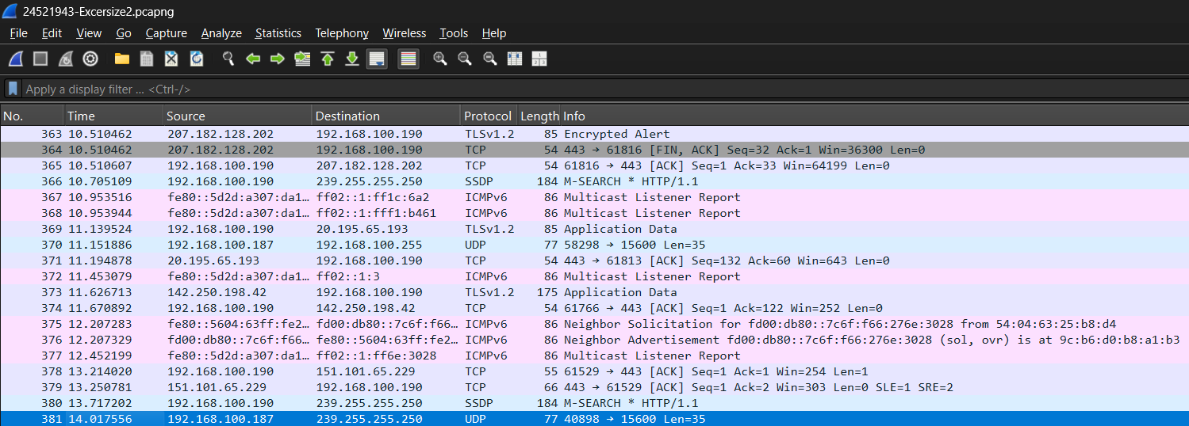

Figure 2. Total packets and time appear doing Exercise 2

Explanation
Exercise | Total packet capture time | Total number of packets captured
1 | 14.017556 | 381
2 | 25.619156 | 476

Question 2: Among the captured packets, how many HTTP packets are there in total?

Evidence:
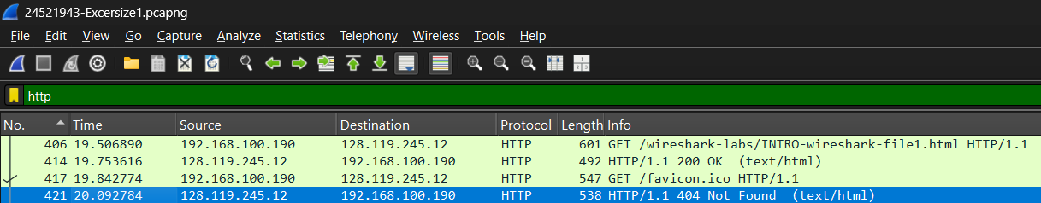

Figure 1. Total HTTP packets appear doing Exercise 1

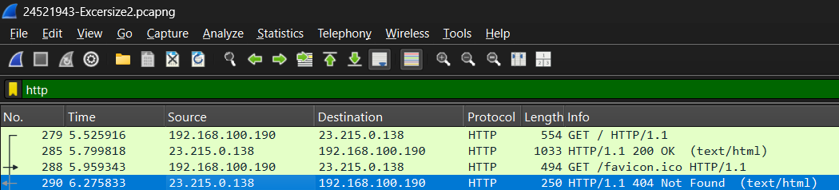

Figure 2. Total HTTP packets appear doing Exercise 2

Explanation:
Exercise | Total HTTP packets
1 | 4
2 | 4

Question 3: List at least 5 different protocols that appear in the protocol column (Protocol) when the "http" filter is not applied when accessing 2 websites.

Evidence:
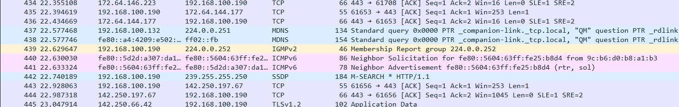

Figure 1. Different protocols appear doing Exercise 1

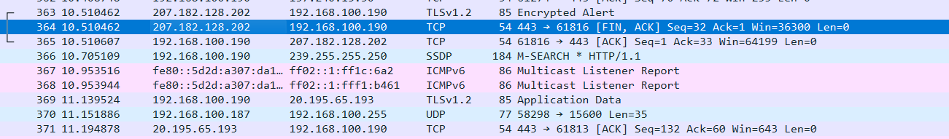

Figure 2. Different protocols appear doing Exercise 2

Explanation:
Protocol | Functions
TCP  (Transmission Control Protocol) | TCP is one of the fundamental protocols of the Internet’s transport layer, ensuring reliable data transmission between devices. It breaks data into packets, sends them across the network, and reassembles. In addition, TCP provides flow control, error checking, and retransmission of lost packets.
TLS v1.2  (Transport Layer Security) | TLS v1.2 is a widely used cryptographic protocol designed to secure communications over the Internet. It provides confidentiality through encryption, integrity through message authentication, and authentication of servers (and optional clients) to prevent impersonation.
SSDP  (Simple Service Discovery Protocol) | SSDP is a network protocol used for automatic discovery of devices and services within a local area network. It operates over HTTPU (HTTP over UDP) and enables devices like smart TVs, media servers, or IoT devices to announce their presence and capabilities, allowing clients to dynamically find and interact with services without manual configuration.
ICMPv6  (Internet Control Message Protocol for IPv6) | ICMPv6 is an integral part of the IPv6 protocol suite, responsible for diagnostic and error-reporting functions. It sends control messages such as “destination unreachable” or “packet too big”. Without ICMPv6, IPv6 networks could not handle routing errors, path MTU discovery, or automatic address configuration effectively.
mDNS  (Multicast Domain Name System): | mDNS provides name resolution within local networks without needing a central DNS server. It uses multicast messages to allow devices to translate hostnames into IP addresses, making it simple to connect to printers, computers, or IoT devices in the same subnet.

Question 4: Identify the first HTTP GET packet sent to the tested website. What is the basic purpose of this packet?

Evidence:
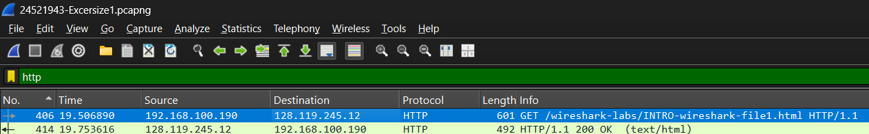

Figure 1. First HTTP GET Packet appears doing Exercise 1

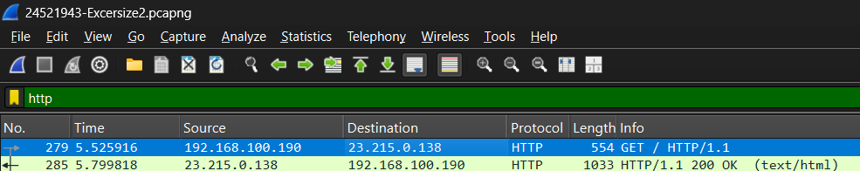

Figure 2. First HTTP GET Packet appears doing Exercise 2

Explanation:
The basic purpose of the first HTTP GET packet is to initiate the actual retrieval of a resource from the web server. Up until this point, the client (your computer) and the server (128.119.245.12 and 23.215.0.138) have already established the lower-layer communication (TCP three-way handshake, and possibly ARP/DNS before that). However, none of that transfers the actual content the user wants to see. The server then responds with a 200 OK, followed by the actual HTML data.

Question 5: Identify the response packet corresponding to the HTTP GET packet in Question 4. What information indicates this?

Evidence:
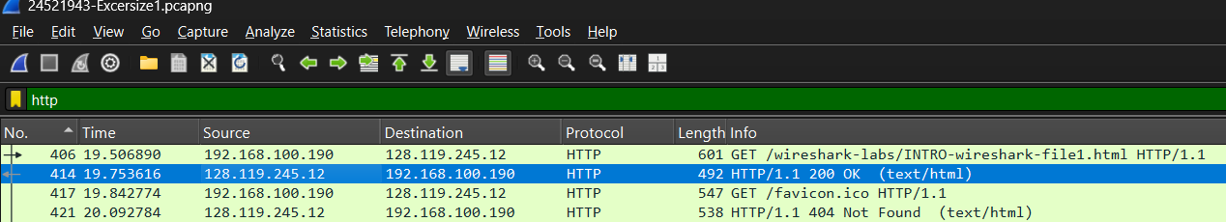

Figure 1. The response packet to HTTP GET Packet appears doing Exercise 1

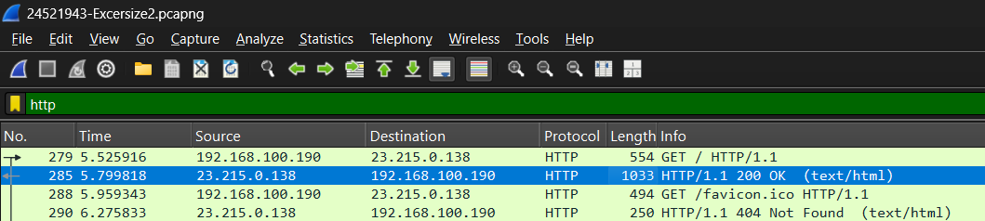

Figure 2. The response packet to HTTP GET Packet appears doing Exercise 1

Explanation:
The response packet corresponding to the HTTP GET request in packet is packet containing the line HTTP/1.1 200 OK (text/html), which indicates that the server successfully processed the client’s request and is returning the requested HTML file. We can identify this as the correct response because it matches the same TCP connection (same source and destination IP addresses and ports), follows directly after the GET request in sequence, and carries the appropriate content type for an HTML page. The status code 200 OK specifically confirms that the resource was found and is being delivered to the client, completing the request-response cycle.

Question 6: Calculate the time from when the first HTTP GET packet was sent until the HTTP 200 OK response packet was received for the tested website.

Evidence:



Figure 1. The values of HTTP GET and HTTP 200 OK packets
appear doing Exercise 1



Figure 2. The values of HTTP GET and HTTP 200 OK packets
appear doing Exercise 2

Explanation:
Exercise | The time from the first HTTP GET packet until the HTTP 200 OK
1 | 0.246726s ≈ 0.247s (247 ms)
2 | 0.273902s ≈ 0.274s (274 ms)

By default, the Time column in Wireshark shows the number of seconds since the capture began. To calculate the delay between them, we simply subtract the two values of two packet (example in Exercise 1: 19.753616 – 19.506890), giving 0.246726 seconds (~274 ms).

Question 7: Content displayed on the website gaia.cs.umass.edu “Congratulations! You've downloaded the first Wireshark lab file!” Is it included in the captured HTTP packets? If yes, find and confirm locate this content in the captured packets.

Evidence:
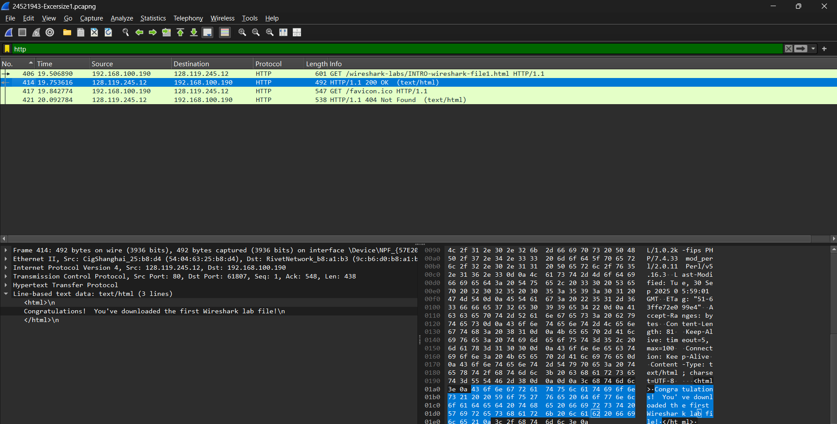
Figure 1. Content displayed on the website gaia.cs.umass.edu
appear in HTTP 200 OK packet doing Exercise 1

Explanation:
Yes, the content “Congratulations! You've downloaded the first Wireshark lab file!” is included in the captured HTTP packets. After the client sends the GET request (frame 406), the server responds with an HTTP/1.1 200 OK message in frame 414, which contains the HTML payload of the requested page. By expanding the Hypertext Transfer Protocol section of this response in Wireshark and viewing the line-based text data, we can clearly locate the congratulatory message, confirming that the displayed content on the website is directly carried within the HTTP response packet.

Question 8: What is the IP address of gaia.cs.umass.edu and the website selected in step 11? What is the computer's IP address in use?

Evidence:



Figure 1. List of IP Addresses appears doing Exercise 1



Figure 2. List of IP Addresses appears doing Exercise 2

Explanation:
- The computer's IP address computer = 192.168.100.190
- The IP address of http://gaia.cs.umass.edu = 128.119.245.12
- The IP address of website selected in step 11 (http://example.com) = 23.215.0.138

Question 9: Through the above packet capture experiment and the packet capture results from Wireshark, let's briefly describe what happens when you start accessing a link to a website until you can view the content on that website.

Evidence:
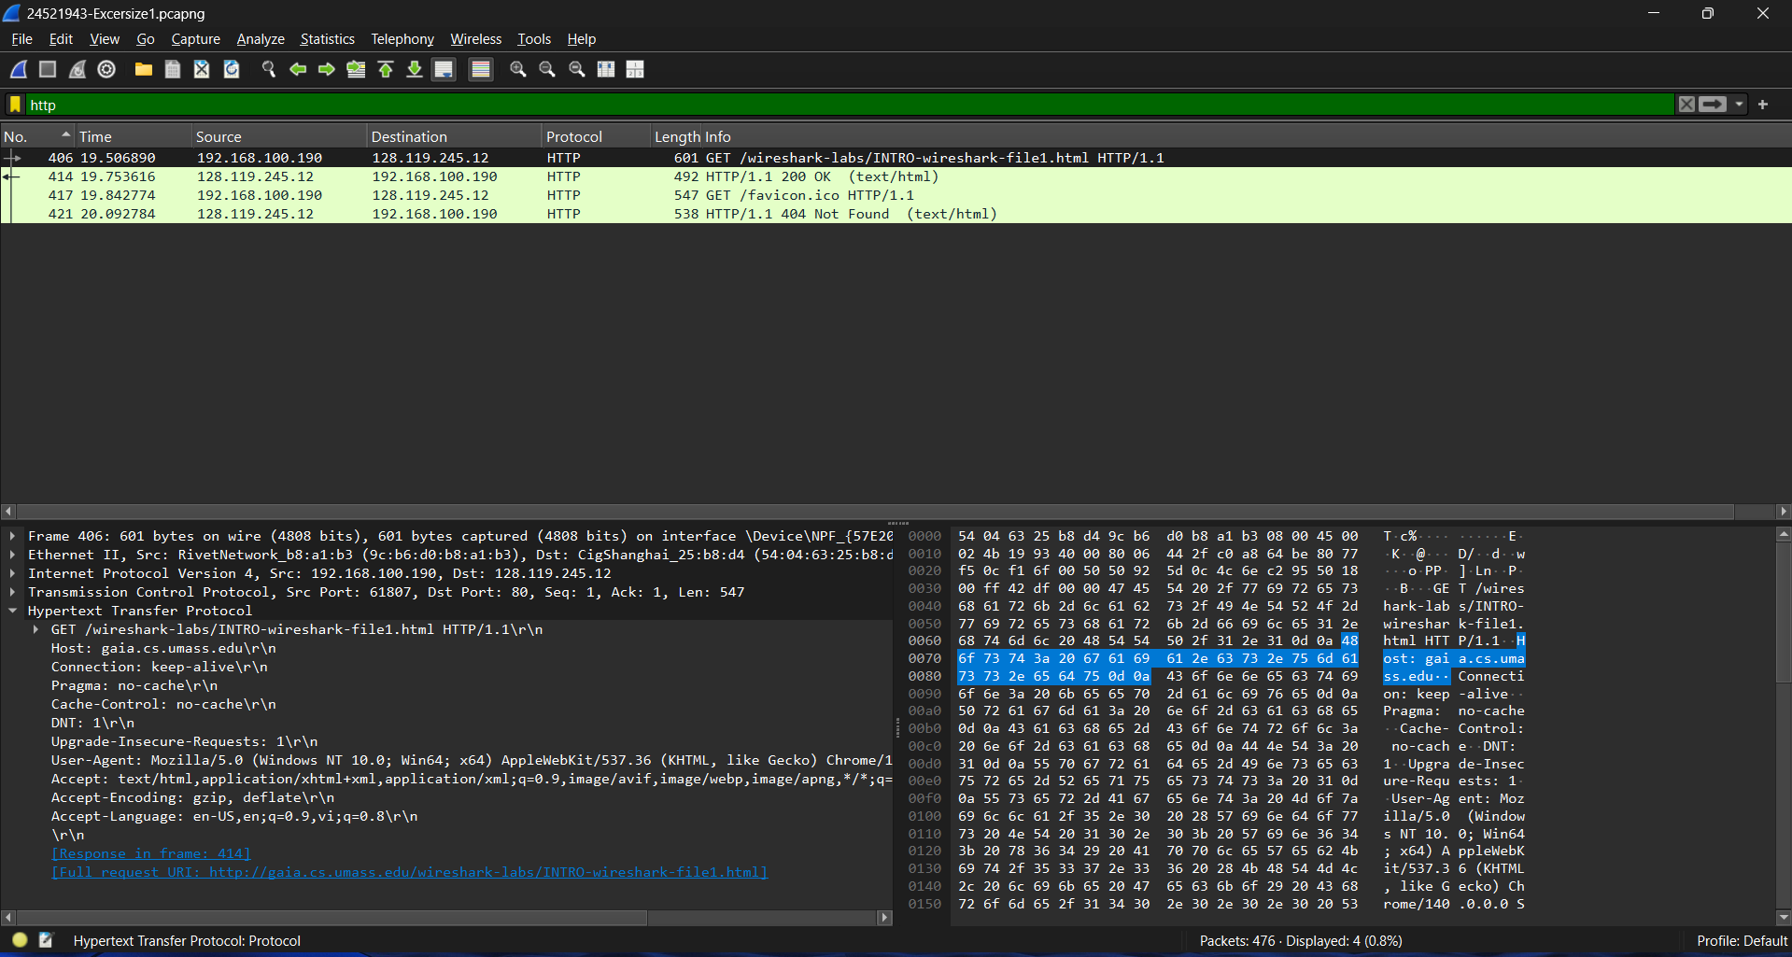

Explanation:
When you type or click on the link (e.g., http://gaia.cs.umass.edu/wireshark-labs/INTRO-wireshark-file1.html), your browser first needs to find the server’s IP address. To do this, it sends a DNS query to a DNS server, which replies with the IP address of the site (in the capture, 23.215.0.138). With this information, your computer can now communicate directly with the web server.
Next, your computer establishes a TCP connection with the server using the three-way handshake (SYN, SYN-ACK, ACK). This step sets up a reliable communication channel so that data can be exchanged without errors or loss. If the website uses HTTPS, an additional TLS handshake would follow to negotiate encryption and security parameters, but in this case, the site uses plain HTTP.
Once the connection is ready, the browser sends an HTTP GET request (frame 406) to the server, asking for the resource “/wireshark-labs/INTRO-wireshark-file1.html”. This request includes information such as the hostname, user agent, and the type of content the browser can accept.
The server processes the request and replies with an HTTP/1.1 200 OK response (frame 414, appears in Hypertext Transfer Protocol panel), confirming that the file exists and will be delivered. Inside the response payload is the actual HTML content of the page. If the page required extra files like images, CSS, or JavaScript, the browser would send additional GET requests for those resources.
Finally, the browser reads the received HTML and renders it into human-readable content on your screen. In this case, the displayed message is:
“Congratulations! You’ve downloaded the first Wireshark lab file!”

Expand: What do you think the IP address is for and is there any other way to see the IP address of a computer and another website? Let's make an illustrative example.

Evidence:
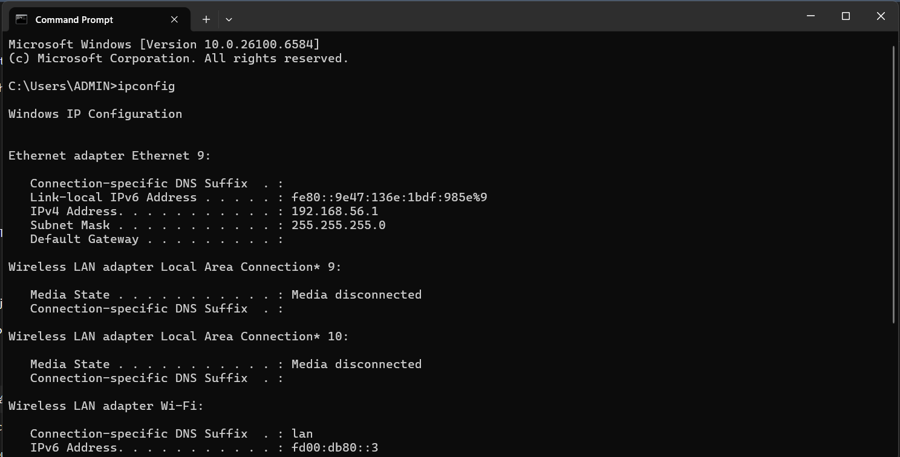

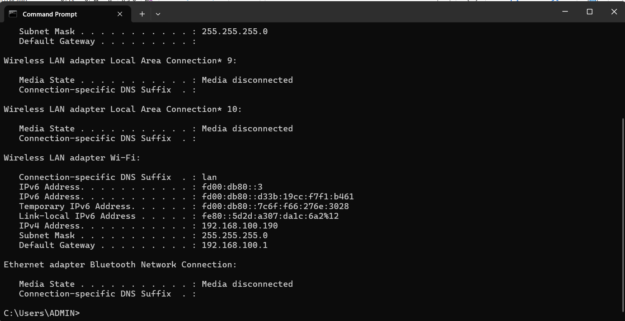

Figure 1 & 2. Using “ipconfig /all” to show all computer’s IP addresses on different components (e.g., Ethernet or Wi-Fi).
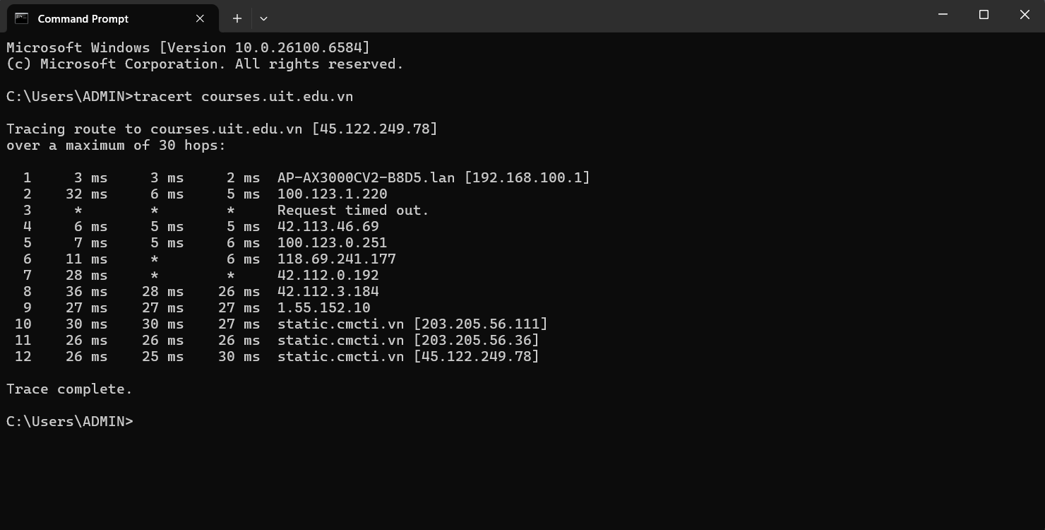
Figure 3. Using “tracert” to shows the route (hops) to the destination website
(e.g., courses.uit.edu.vn )

Explanation:
ipconfig /all: This command displays detailed configuration information for all network interfaces on your computer. It shows your local IPv4 and IPv6 addresses, default gateway, subnet mask, DNS servers, and MAC address. This is useful to identify the IP address your computer is currently using, along with how it connects to the network (wired, wireless, or virtual adapter). For example, you might see IPv4 Address: 192.168.100.190, which confirms your computer’s current IP address.
tracert courses.uit.edu.vn: This command traces the path that packets take from your computer to the destination server (in this case, the UIT courses website). It lists each router (hop) along the way, showing how data travels across the Internet until it reaches the website’s IP address. This not only confirms the IP address of the website (resolved at the end of the trace, e.g., the main IP Address of this website 45.122.249.78) but also helps you see where delays or connectivity issues may occur. For instance, running this command will show the final hop as the UIT server’s IP address, proving how your request reaches that website.

END

